- Create user with name Techie and provide sudo access to user:
Sudo useradd
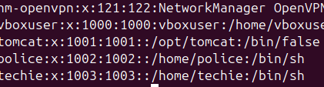
2) Navigate to the home directory:
~
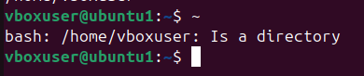
3) Create a new directory:
Mkdir directory name (BMW)
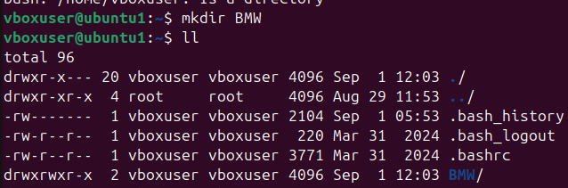
4) List the contents of a directory:
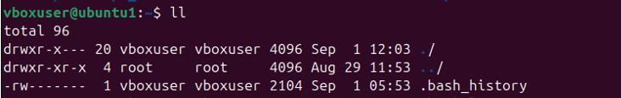

5) Change the current directory:
Cd param/
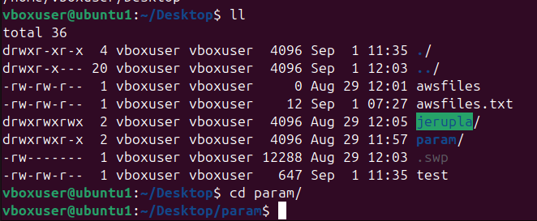
6) Create a new empty file:
Touch (testing)
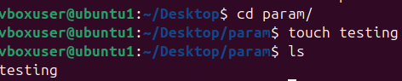
7) View the contents of a file:
Cat file name (test)
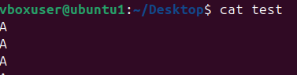

8) Copy a file to another location:
cp file(awsfiles ) to directory param.
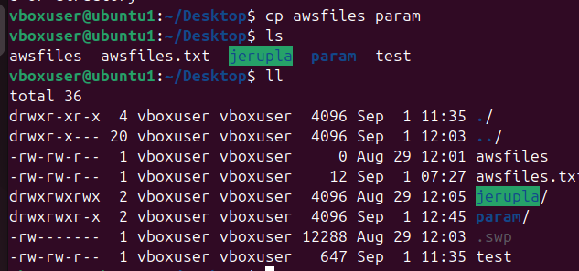

9) Move a file to another location:
Mv file (test) to directory Jerupla.
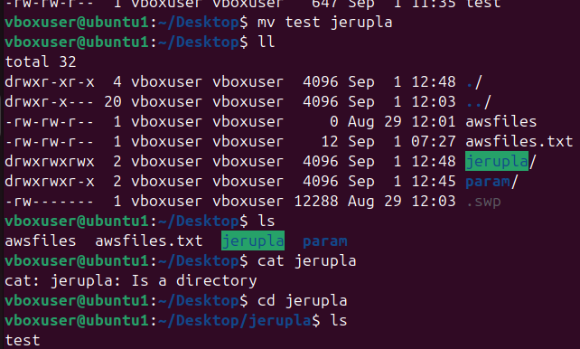
10) Rename a file:
Renamed (file) awsfiles to (landroverdoc)
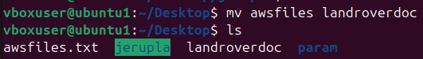

11) Delete a file:
Deleted landrover file.
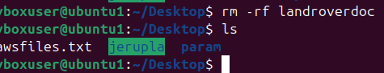
12) Grant or revoke permissions on a file or directory:
13) View the current date and time:
Command is date.
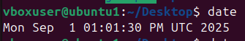
14) Check the system uptime:
Command is uptime.
15) View the running processes:
Command To check the current running process is (ps -ef)
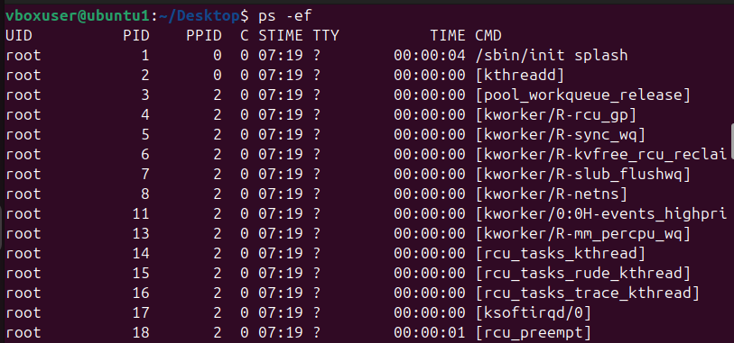

16) Kill a running process:
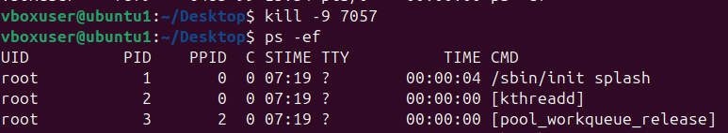

17) Install a package using the package manager .
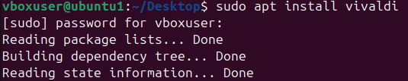
18) Update the system packages:
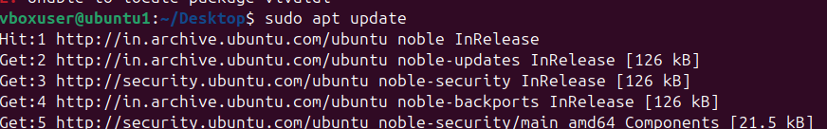

19) Create a symbolic link:
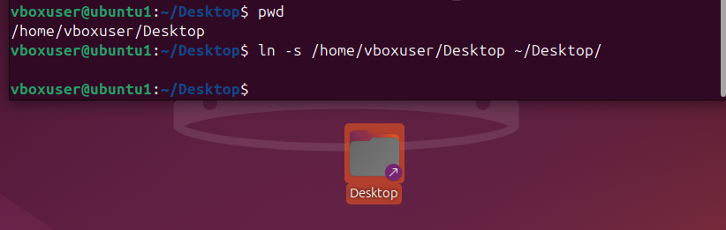

20) Search for files using the find command:
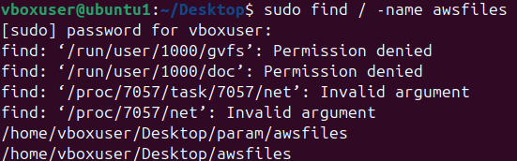
21) Compress and decompress files using tar:
22) Monitor system resources with top or htop:
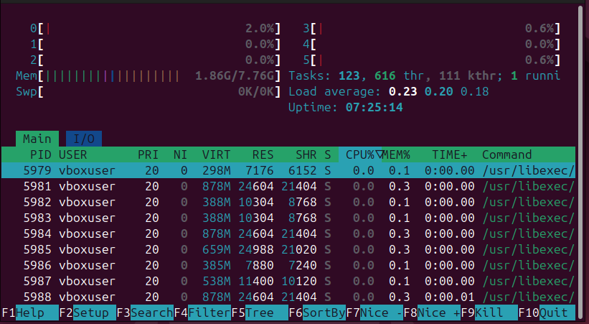
23) Create and manage user groups:
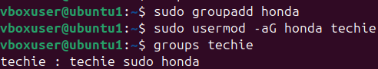
24) Set up SSH password less authentication:
25) Monitor log files using tail or grep:
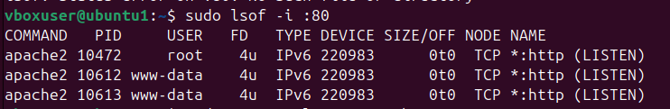
26) Set up a web server (e.g., Apache or Nginx):
Installed apache2 server with the below command.
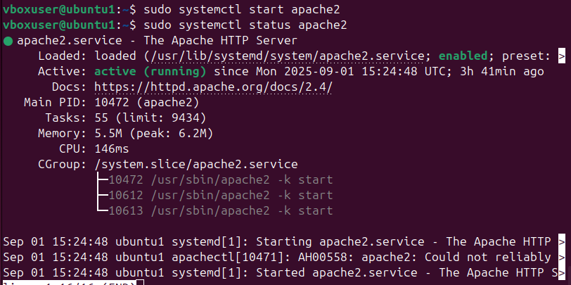
27) Configure and secure a MySQL Database:
Installed mysql server using systemctl command.
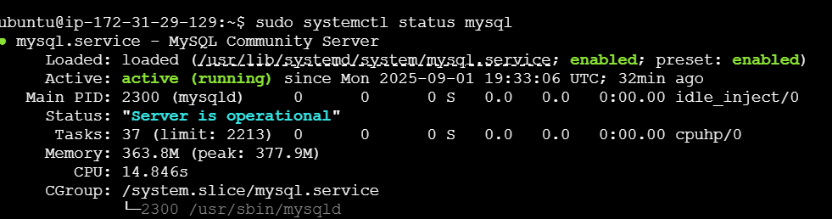
28) Set up a Application Server (e.g.,Apache Tomcat)
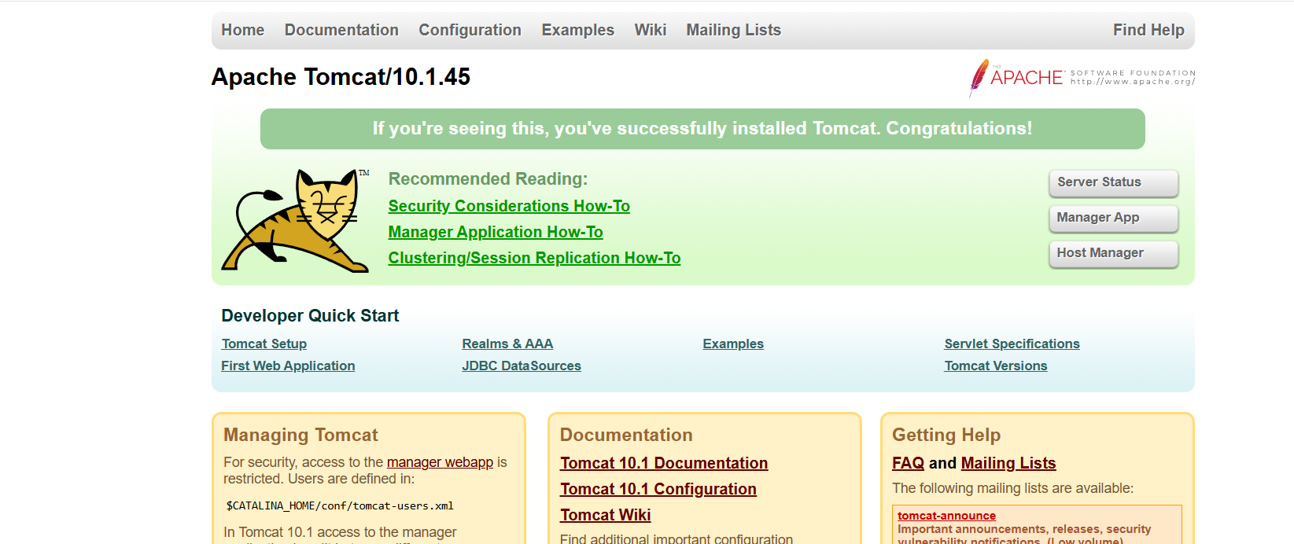
29) create a service file for Apache Tomcat.(Should execute by using systemtctl command)
30) Print specific columns from a delimited file:
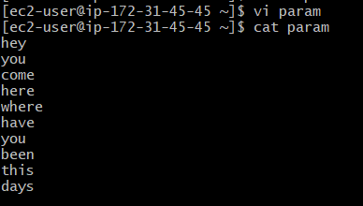
31) Filter and print lines based on a specific pattern or condition:
Use grep “Pradesh” india to print the specific pattern.
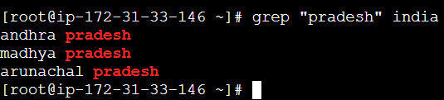
32) Calculate and print the average, sum, or other statistics of a column. use awk ( sum += $1-$5) end (print sum/NR).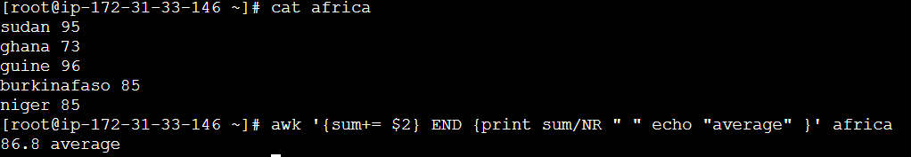
33) Perform string manipulation, such as extracting substrings or changing case.
34) Count the occurrences of a specific pattern in a file:
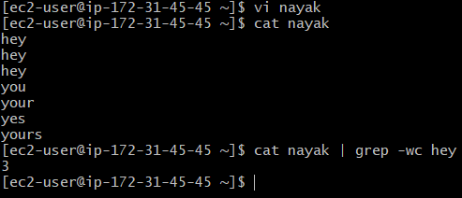
35) Sort lines based on a specific field or column.
36) Merge multiple files based on a common field or column.
37) Substitute text in a file using search and replace.
38) Delete specific lines based on a pattern or line number.
39) Append or insert text before or after a specific pattern or line.
40) Print only specific lines from a file:
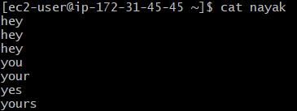

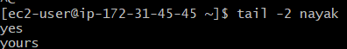
41) Copy file from linux to windows machine
42) 5 use cases for AWK and 5 use cases for sed

